Geometry: Unit 3, Lesson 5
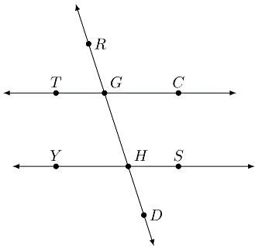
- Lines $TC$, $YS$, and $RD$ are shown. $\overset{⃡}{TC}∥\overset{⃡}{YS}$ and $\overset{⃡}{RD}$ is a traversal. Give an example of an angle pair that are consecutive exterior angles.

$∠RGC$ and $∠SHD$

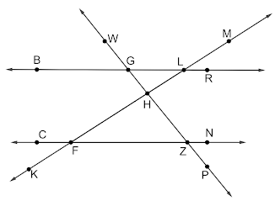
- Lines $BR$, $CN$, $PW$, and $KM$ are shown. $\overset{⃡}{BR}∥\overset{⃡}{CN}$ with traversals $\overset{⃡}{PW}$ and $\overset{⃡}{KM}$. What type of angles are $∠ZFH$ and $∠GLH$

Alternate interior angles

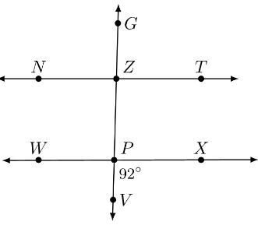
- Lines $NT$, $WX$, and $GV$ are shown. $\overset{⃡}{WX}∥\overset{⃡}{NT}$, $\overset{⃡}{GV}$ is a traversal, and $m∠VPX=92°$. What angle has a measure of $\left(180-92\right)°$?

$$∠WPV$$

